Software Requirement Specification

For

Food Mate- Online Food Delivery System

Student Name | Student ID | Remarks
Sushpana Chuadhary | K231839
Borkotur Rahman | K240384
Shourav Islam | K230724
Wasik Gaus | K240381 | New to the group
Gargesh Lamichhane | K240209 | Really didn’t try to do anything. Most of the time his device is on update or not working.

Contents
1.INTRODUCTION 4
1.1 Purpose 4
1.2 Document Conventions 4
1.3 Intended Audience and Reading Suggestions 4
2. OVERALL DESCRIPTION 4
2.1 Product Perspective & Business Context 4
2.2 Product Functions Summary 4
2.3 User Classes and Characteristics (Stakeholders) 5
2.4 Operating Environment 5
2.5 Design and Implementation Constraints 5
2.6 User Documentation 5
2.7 Assumptions and Dependencies 6
3. EXTERNAL INTERFACE REQUIREMENTS 6
3.1 User Interfaces & UI Storyboard 6
3.2 Hardware Interfaces & System Configuration 8
3.3 Software Interfaces & 3-Tier Architecture 9
3.4 Communications Interfaces & Protocols 9
4. SYSTEM FEATURES AND USE CASES 9
4.1 User Registration and Authentication 9
4.2 Customer Ordering Features 10
4.3 Restaurant Management Features 10
4.4 Delivery Partner Module 10
4.5 Administrator Governance Features 10
4.6 Notification & Payment Services 10
4.7 Use Case Diagram & Operational Specifications 11
5. DATA AND SYSTEM MODELLING 13
5.1 Data Requirements Overview 13
5.2 Data Flow Diagram – Level 0 (Context Model) 13
5.3 Data Flow Diagram – Level 1 (Operational Decomposition) 14
5.4 Entity Relationship Diagram (ERD & 3NF Schema) 14
5.5 Class Diagram (Object-Oriented Architecture) 15
5.6 Sequence Diagram (Order Lifecycle) 17
5.7 Core Data Dictionary 17
6. OTHER NONFUNCTIONAL & COMPLIANCE REQUIREMENTS 19
6.1 Performance & Scalability Requirements 19
6.2 Safety, Reliability & Quality Attributes 19
6.3 Security Controls & Cryptographic Hashing 19
6.4 Privacy & Data Protection Impact Assessment (DPIA) 19
6.5 Ethical Considerations & Business Rules 20
7. PROJECT PLANNING, TESTING AND IMPLEMENTATION 20
7.1 OrdoACustomer Team Responsibilities & Workload Allocation 20
7.2 Test Strategy & System Test Plan 22
7.3 Implementation Roadmap (Implemented / Planned / Future) 23
References 23

INTRODUCTION

Purpose
This Software Requirements Specification (SRS) establishes the business, functional, architectural, data, security, and quality requirements for FoodMate, an integrated multi-restaurant food delivery management system for metropolitan Melbourne. Developed for the CPRO306 Capstone Project, this document serves as the formal baseline for development, verification, deployment, and stakeholder sign-off (Sommerville 2016, p. 84).
FoodMate was developed using an Agile methodology, organised into iterative sprints across the 12-week CPRO306 timeline. This allowed requirements, storyboards, and database design to be refined incrementally with feedback between iterations.

Document Conventions
This document adheres to standard IEEE 830 and academic formatting guidelines:
- Section titles and key terms appear in bold; database entities appear in uppercase (e.g., `ORDER`, `CUSTOMER`).
- Requirements are coded with unique identifiers (e.g., `FR-AUTH-01`, `BR-01`).
- The term "System" refers to the holistic FoodMate software ecosystem.

Intended Audience and Reading Suggestions
- Developers & Engineers: Focus on Sections 3, 4, 5, and 6 for architecture, schema design, and security protocols.
- Project Assessors & Evaluators: Review Sections 1, 2, 7, and References.
- QA Testers: Refer directly to Section 7.2 for test execution procedures.

OVERALL DESCRIPTION

Product Perspective & Business Context
FoodMate is an independent, three-tier web application operating within Melbourne's digital hospitality economy. By connecting consumers directly to local dining vendors without customer service fees, FoodMate enhances vendor transparency and reduces checkout abandonment.

Product Functions Summary
FoodMate provides role-specific functionality across four primary operational modules:
- Customer Module: Suburb-based search, dietary filtering, cart management, zero-fee checkout, and live order tracking.
- Restaurant Module: Menu item CRUD, stock availability toggles, incoming order queues, and revenue reporting.
- Delivery Partner Module: Nearby job alerts, route details, and multi-stage status milestone updating.
- Administrator Module: Platform governance, merchant onboarding approvals, and financial transaction audits.

User Classes and Characteristics (Stakeholders)
FoodMate engages four internal user groups and two external service providers (Table 2.1).
Table 2.1: FoodMate Stakeholder & User Role Matrix
Stakeholder / User | Role | Main Needs & Interaction
Customer | End consumer ordering meals | Suburb search, dietary filter, zero-fee checkout, live tracking, and reviews.
Restaurant User | Vendor kitchen and management staff | Order queue acceptance, menu catalog control, stock toggles, and daily sales.
Delivery Partner | Independent courier driver | Job dispatch, pickup/delivery navigation, and onetap milestone logging.
Administrator | System operations manager | Platform governance, merchant verification, dispute resolution, and audit logs.
Payment Gateway | External processor (Stripe/PayPal) | Tokenized transaction authorization and PCI-DSS compliant settlement.

Operating Environment
- Client Environment: Modern desktop, tablet, and mobile browsers.
- Server Environment: Cloud Linux VPS running Apache 2.4/Nginx, PHP 8.1+, and MySQL 8.0+ / MariaDB.

Design and Implementation Constraints
- Technical Constraints: Adherence to PHP PSR-12 coding standards and PDO prepared statement execution.
- Academic & Time Constraints: Bounded by the 12-week CPRO306 Capstone trimester schedule.
- Hosting Constraints: Standard cloud VPS quotas with preconfigured limits.

User Documentation
System documentation includes online help FAQs, merchant onboarding manuals, and administrator runbooks.

Assumptions and Dependencies
- Stable client internet access on modern HTML5-compliant web browsers.
- Continuous availability of external payment gateway APIs.
- Restaurants manage their own kitchen preparation hardware.

EXTERNAL INTERFACE REQUIREMENTS

User Interfaces & UI Storyboard
FoodMate applies core Human-Computer Interaction (HCI) principles (Shneiderman et al. 2016, p. 115): visual consistency, immediate feedback, error prevention, and a 3-click ordering paradigm.
Customer Interface Screens
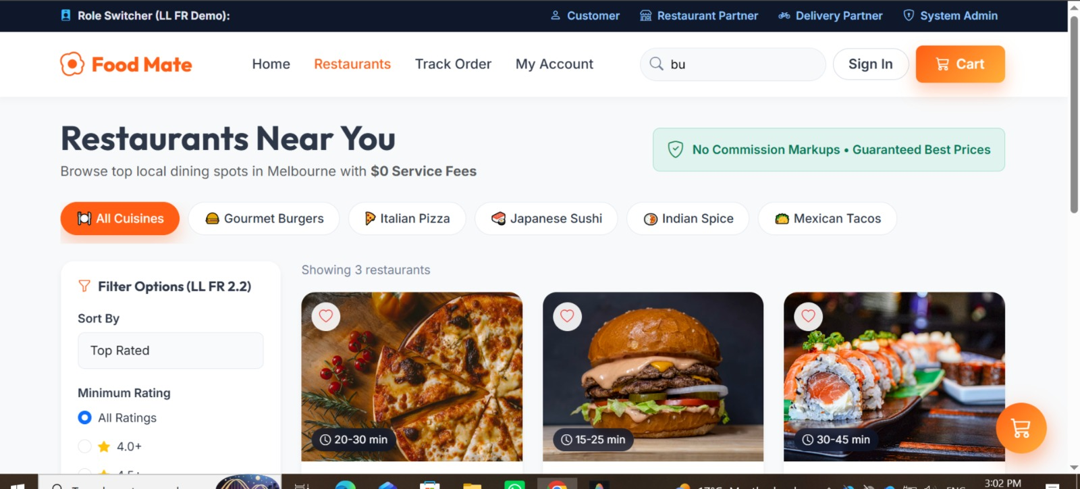
Explanation: Melbourne suburb search, category filter pills (Burgers, Pizza, Sushi), and featured restaurant cards.

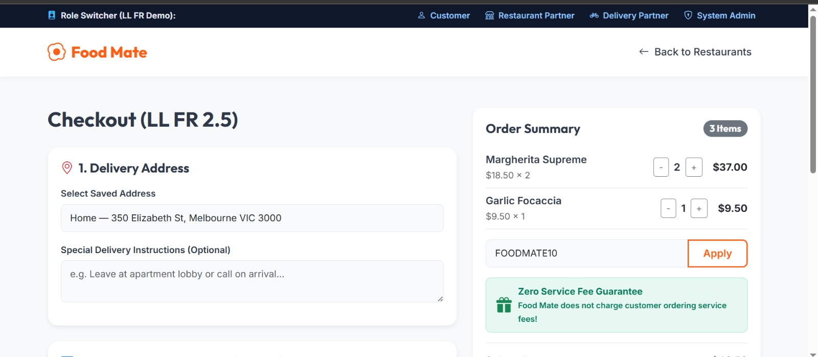
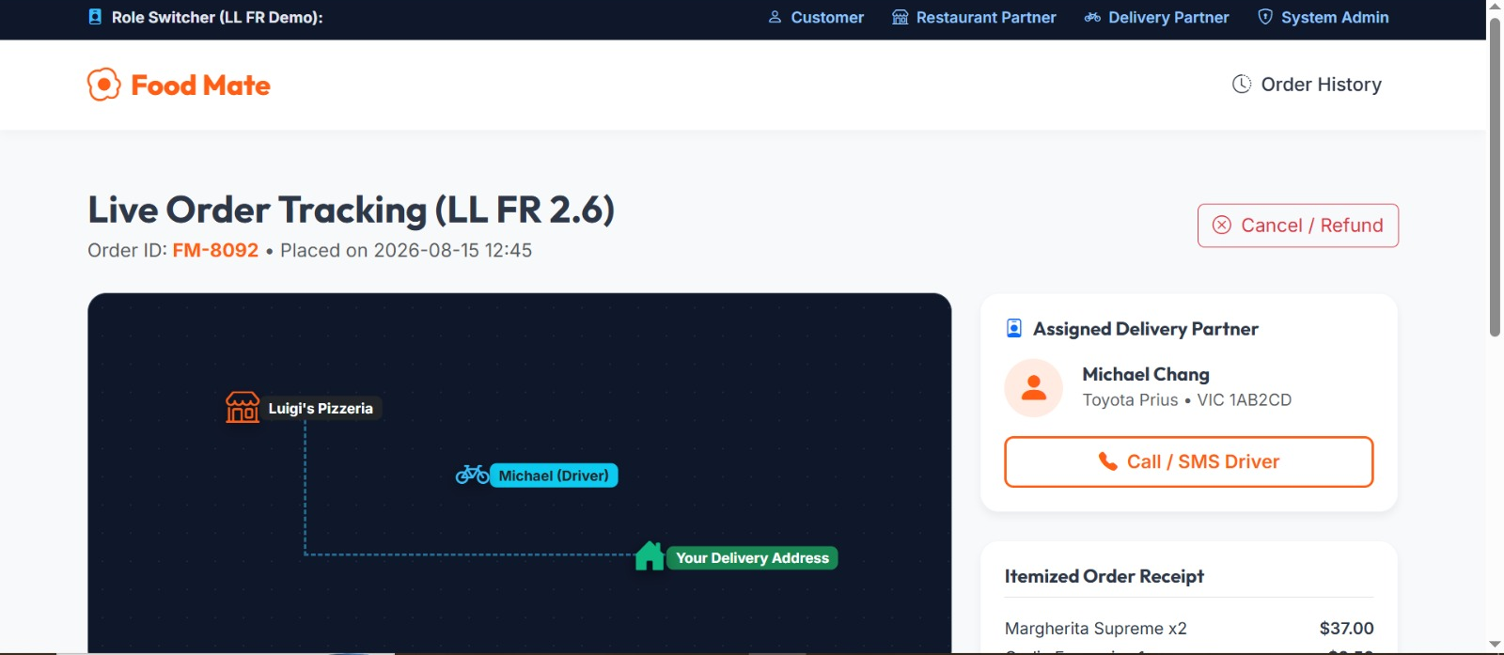
Input form: Itemized cost breakdown, address selection, coupon input, and zero-service-fee payment processing.
Output view: Multi-step progress tracker (Placed → Preparing → Out for Delivery → Delivered).

Merchant, Courier & Administrator Interfaces

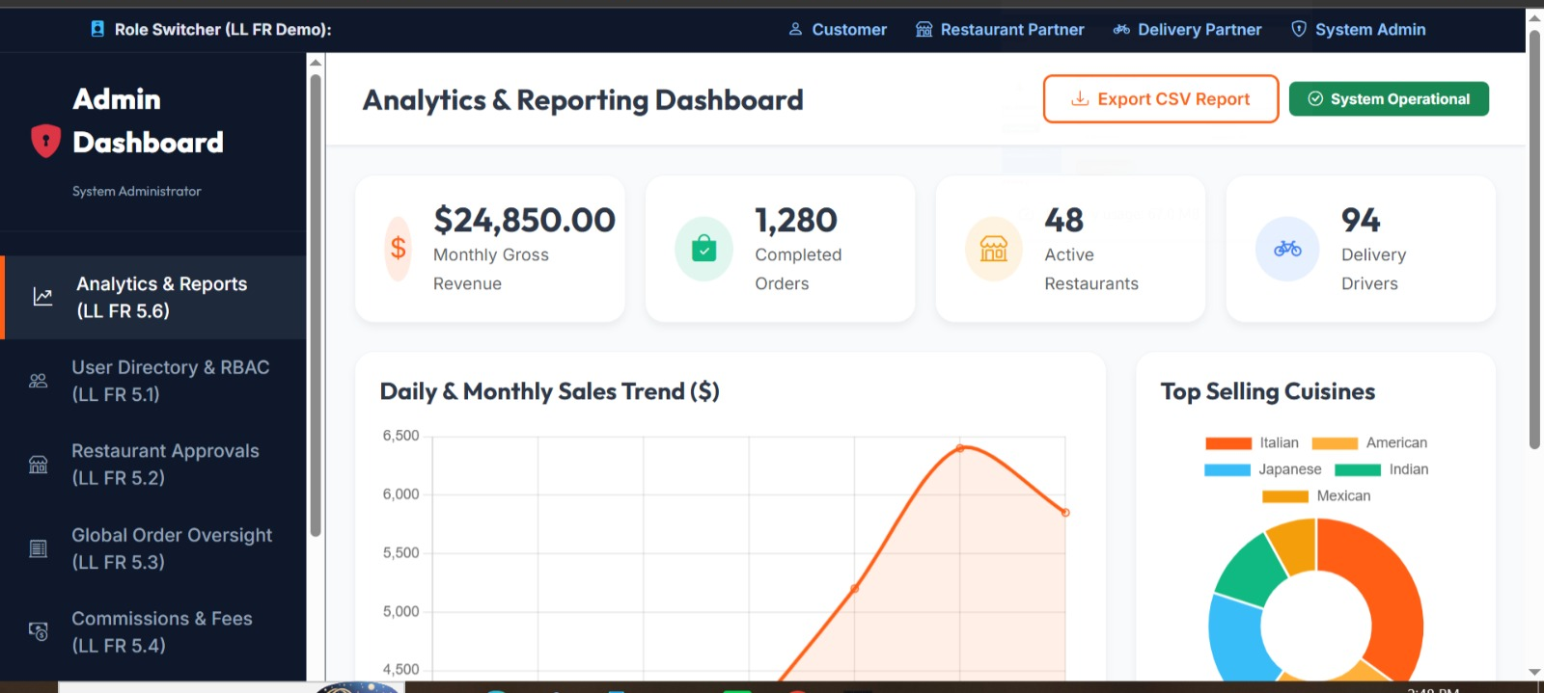
Explanation: Merchant control panel showing daily sales, active orders, and operating hours.
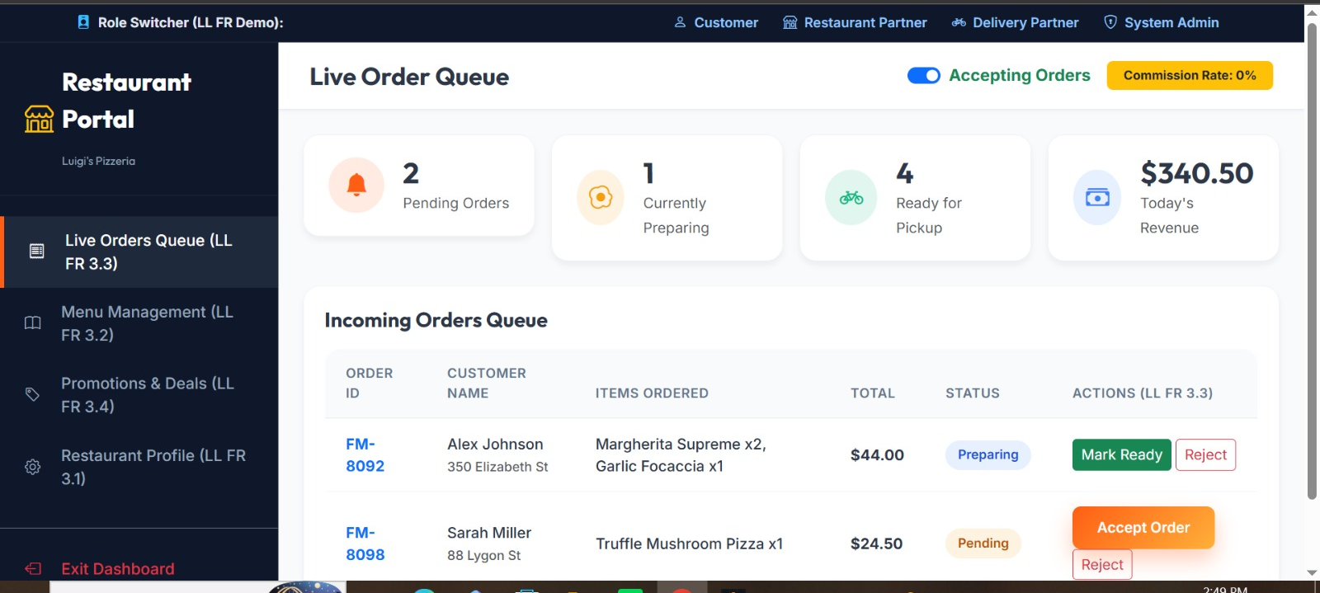

Explanation: Live kitchen order queue enabling staff to accept tickets and set prep times.

Hardware Interfaces & System Configuration
Hardware configurations across all operational nodes are detailed in Table 3.1. Table 3.1: Hardware Interface Requirements
Deployment Node | Minimum Hardware  Specification | Recommended Hardware Specification
Customer Device | Smartphone/PC; 2GB RAM; 1.0 GHz CPU; 1 Mbps internet. | Modern smartphone/PC; 4GB+ RAM; 4G/5G/Broadband.
Restaurant Device | Tablet/Laptop; 4GB RAM;  1024x768 display; broadband. | Desktop/Order Tablet; 8GB RAM; high-speed Wi-Fi.
Delivery Partner Device | GPS smartphone; 3GB RAM; 4G LTE mobile data. | iOS 14+ / Android 10+ phone; 4GB RAM; active GPS.
Production Server | Dual-Core VPS; 4GB RAM; 40GB SSD; 100 Mbps uplink. | Quad-Core VPS; 8GB–16GB RAM; 100GB NVMe SSD; 1 Gbps uplink.

Software Interfaces & 3-Tier Architecture
FoodMate is implemented on a modular three-tier architecture (Fielding 2000, p. 45; Pressman & Maxim 2020, p. 340):
- Presentation Tier: HTML5, Vanilla CSS3, JavaScript (ES6+), and Bootstrap 5.3.
- Application Tier: PHP 8.1+ executing business rules, role-based authorization, and RESTful routing.
- Data Tier: MySQL 8.0+ database engine enforcing relational ACID transactions.

Communications Interfaces & Protocols
- HTTPS/TLS 1.3: Encrypted client-server exchange across all endpoints.
- JSON REST Endpoints: Asynchronous AJAX transfer for cart math and status updates.
- Database Connectivity: PDO with parameter binding to eliminate SQL injection vulnerabilities.

SYSTEM FEATURES AND USE CASES

User Registration and Authentication
- FR-AUTH-01 (High): Authenticate Customers, Restaurant Users, Delivery Partners, and Admins via secure email/password sessions.
- FR-AUTH-02 (High): Enforce Role-Based Access Control (RBAC) across all protected views (Stallings 2018, p. 112).

Customer Ordering Features
- FR-CUST-01 (High): Provide suburb search, dietary filters (Halal, Vegan, Gluten-Free), and responsive menu views.
- FR-CUST-02 (High): Maintain shopping cart state with zero service fees and itemized pricing.
- FR-CUST-03 (High): Display live order progress (Preparing, Out for Delivery, Delivered).

Restaurant Management Features
- FR-REST-01 (High): Enable restaurant users to create, update, price, and disable menu items.
- FR-REST-02 (High): Display real-time incoming orders with accept/reject and preparation time toggles.

Delivery Partner Module
- FR-DELI-01 (High): Present nearby delivery jobs with pickup/drop-off addresses and payout rates.
- FR-DELI-02 (High): Log courier delivery transitions (Picked Up, Out for Delivery, Delivered).

Administrator Governance Features
- FR-ADMN-01 (High): Verify and onboard new restaurant merchant applications.
- FR-ADMN-02 (High): Monitor platform transaction logs, commission revenues, and user moderation.

Notification & Payment Services
- FR-NOTF-01 (Medium): Dispatch email and onscreen notifications upon order status changes.
- FR-PAYM-01 (High): Authorize card payments securely via tokenized gateway APIs without storing raw card data.

Use Case Diagram & Operational Specifications
System functional boundaries are captured in the system use case model.
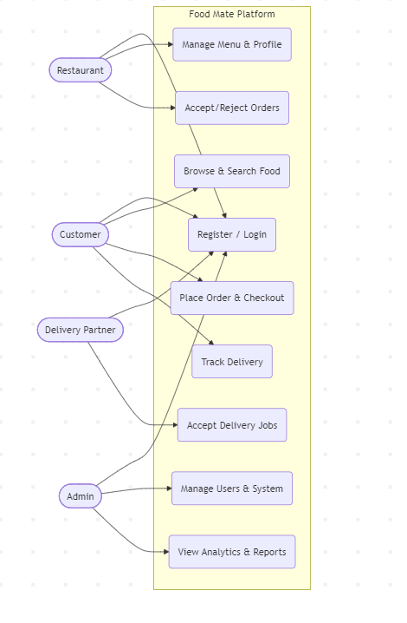

Explanation: Illustrates the core operational interactions among the four primary actors (Customer, Restaurant User, Delivery Partner, Administrator) and external payment services. Primary use case flows are outlined in Table 4.1.

Table 4.1: Core System Use Case Specifications
Use Case Name | Primary Actor | Preconditions | Main Success Flow | Postcondition / Outcome
UC-01: Register & Login | All Users | Valid credentials. | User submits credentials; system validates bcrypt hash and creates session. | User authenticated to role dashboard.
UC-02: Search  & Order | Customer | System catalog active. | Customer searches suburb, selects dishes, and submits cart. | Order created in database.
UC-03: Process  Payment | Customer | Items in cart. | Customer authorizes card charge via payment gateway tokenization. | Payment verified; invoice issued.
UC-04: Manage Menu | Restaurant User | Merchant logged in. | Vendor edits item prices, descriptions, and stock availability toggles. | `MENU_ITEM` table updated.
UC-05: Fulfill  Delivery | Delivery Partner | Driver assigned. | Courier marks order as "Picked Up" and updates status to "Delivered". | Delivery completed; driver credited.
UC-06:  Administer | Administrator | Admin logged in. | Admin reviews merchant registrations and updates platform | Platform records and settings updated.

DATA AND SYSTEM MODELLING

Data Requirements Overview
FoodMate manages relational data across five core domains: user credentials, restaurant profiles and menus, customer orders, delivery assignments, and payment audit records.

Data Flow Diagram – Level 0 (Context Model)
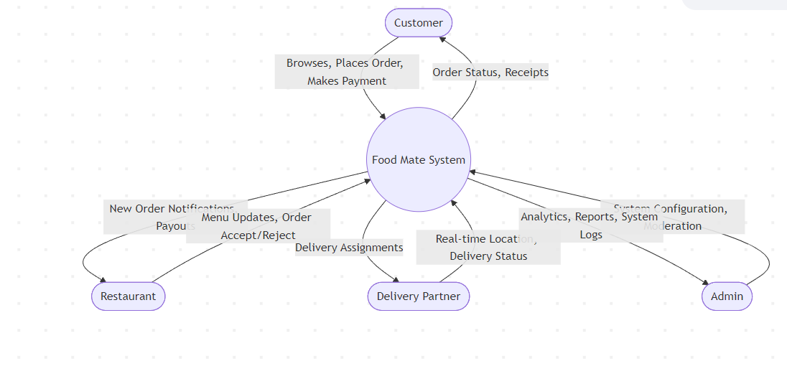
The Context Diagram establishes the global boundary of FoodMate and its external data exchanges.

Explanation: Models FoodMate as a central software process interacting with four external entities (Customer, Restaurant, Delivery Partner, Admin). Data inflows include customer orders, merchant menu updates, driver status changes, and admin commands; outflows include order receipts, dispatch orders, payouts, and analytical reports.

Data Flow Diagram – Level 1 (Operational Decomposition)
The Level 1 DFD decomposes the system into four major operational sub-processes.
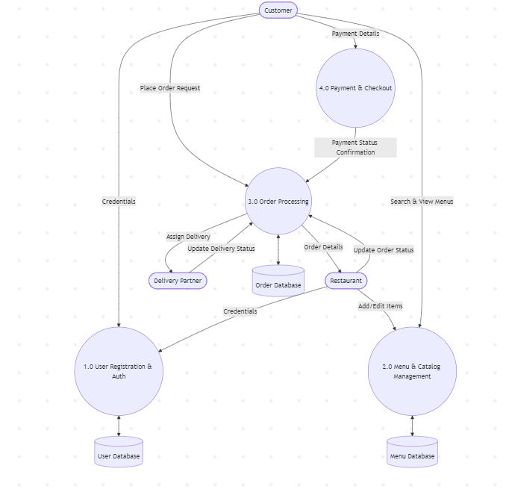

Explanation: Decomposes operations into Process 1.0 (User Registration & Auth), Process 2.0 (Menu Management), Process 3.0 (Order Processing), and Process 4.0 (Payment & Checkout), each linked to dedicated relational stores (`User Database`, `Menu Database`, `Order Database`).

Entity Relationship Diagram (ERD & 3NF Schema)
The relational database schema is normalized to 3rd Normal Form (3NF) to eliminate update anomalies (Elmasri & Navathe 2017, p. 280).
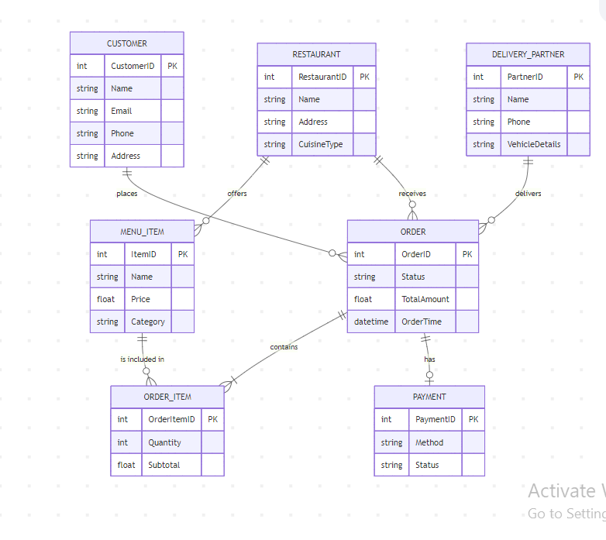

Explanation of Relational Structures:
- `CUSTOMER (1:N) ORDER`: Customer places multiple orders; each order belongs to one customer via `CustomerID` (FK).
- `RESTAURANT (1:N) MENU_ITEM & ORDER`: Restaurant manages multiple menu items and receives multiple orders via `RestaurantID` (FK).
`ORDER (1:N) ORDER_ITEM (N:1) MENU_ITEM`: Composite associative line-item entity linking orders and dishes.
- `DELIVERY_PARTNER (1:N) ORDER`: Driver fulfills multiple assigned orders via `PartnerID` (FK).
- `ORDER (1:1) PAYMENT`: Each order is linked to one payment record via `OrderID` (FK).

Class Diagram (Object-Oriented Architecture)
The object-oriented design is modeled in the system class diagram.
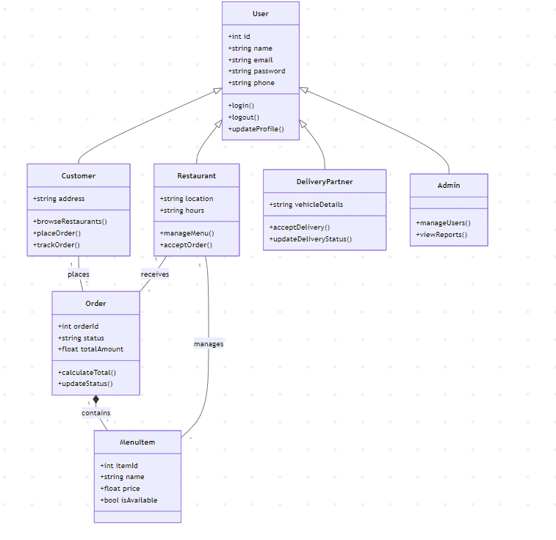

Explanation: Utilizes inheritance from a base `User` class (`id`, `name`, `email`, `password`, `login()`, `logout()`) to specialized subclasses `Customer`, `Restaurant`, `DeliveryPartner`, and `Admin`. The `Order` class aggregates `MenuItem` instances and handles status transitions and pricing logic.

Sequence Diagram (Order Lifecycle)
The runtime sequence for placing an order is captured in the system sequence diagram.
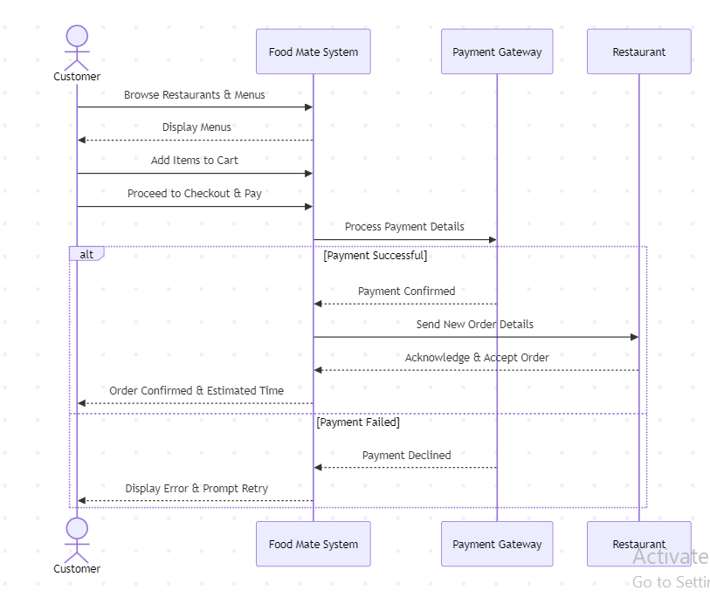

Explanation: Traces interactions between `Customer`, `FoodMate System`, `Payment Gateway`, and `Restaurant`, verifying payment authorization before dispatching the order ticket and returning an estimated delivery time.

Core Data Dictionary
Table 5.1 details high-priority schema fields relevant to core order and payment workflows.
Table 5.1: High-Priority Data Dictionary

Table | Field Name | Data Type | Key | Description | Security /  Privacy  Classification
CUSTOMER | `CustomerID` | INT(11) | PK | Unique customer identifier. | Public  Identifier
CUSTOMER | `Name` | VARCHAR(100) | None | Full customer name. | PII  (Confidential)
CUSTOMER | `Email` | VARCHAR(100) | Unique | Login email credential. | PII /  Confidential
CUSTOMER | `Password` | VARCHAR(255) | None | Cryptographic password hash. | Highly  Confidential  (bcrypt)
CUSTOMER  address. | `Address`  (Masked postdelivery) | VARCHAR(255) | None | Residential delivery | Location PII
RESTAURANT | `RestaurantID` | INT(11) | PK | Unique restaurant identifier. | Public  Identifier
RESTAURANT | `Name` | VARCHAR(100) | None | Registered trading name. | Public  Business Data
ORDER | `OrderID` | INT(11) | PK | Unique order tracking ID. | Operational Data
ORDER | `CustomerID` | INT(11) | FK | References  `CUSTOMER(CustomerID)`. | Internal  Relational Key
ORDER | `TotalAmount` | DECIMAL(10,2) | None | Total order billing in AUD. | Financial  Audit Record
ORDER | `Status` | VARCHAR(30) | None | Order lifecycle state. | Operational State Data
PAYMENT | `PaymentID` | INT(11) | PK | Payment transaction ID. | Financial  Audit Record
PAYMENT | `TransactionRef` | VARCHAR(100) | None | Payment gateway token. | Gateway Authorization  Token

OTHER NONFUNCTIONAL & COMPLIANCE REQUIREMENTS

Performance & Scalability Requirements
- NFR-PERF-01: Average page render times shall not exceed 2.0 seconds on standard 4G mobile connections.
- NFR-SCAL-01: System shall support 500 concurrent users without database deadlocks or performance degradation.

Safety, Reliability & Quality Attributes
- NFR-RELI-01: Maintain 99.5% operational uptime; all checkout operations executed under ACID transaction blocks.
- NFR-USAB-01: Intuitive interface requiring no more than 3 clicks to reach checkout (Shneiderman et al. 2016, p. 78).
NFR-COMP-01: Uniform cross-browser compatibility across Chrome, Safari, Edge, and Firefox.

Security Controls & Cryptographic Hashing
- Authentication: All passwords salted and hashed using bcrypt (cost factor 12) (Stallings 2018, p. 195).
- Injection Defense: 100% of SQL queries executed through PHP PDO prepared statements with strict input escaping.
- Transport Security: Strict HTTPS enforcement across all endpoints utilizing TLS 1.3 certificates.
- Data Encryption: Sensitive fields such as delivery address and payment tokens are encrypted at rest alongside bcrypt-hashed credentials.

Privacy & Data Protection Impact Assessment (DPIA)
Aligned with the Australian Privacy Principles (APPs), FoodMate practices data minimization: customer delivery addresses are visible to couriers only during active delivery transit and masked once orders are completed. Table 6.1 details the project DPIA.
Table 6.1: FoodMate Data Protection Impact Assessment (DPIA)
Asset / Risk Scenario | Privacy Impact | Likelihood | Severity |  | Mitigation Strategy | Residual Risk
Customer  Personal &  Address Data | Unauthorized disclosure of residential location and phone. | Low | High |  | Strict RBAC; dynamic address masking postdelivery; PDO prepared queries. | Low
User  Authentication Credentials | Credential theft or database leak leading to account compromise. | Low | Critical |  | Strong bcrypt hashing (cost 12); login rate limiting. | Low
Payment Card  Information | Interception of cardholder payment data during checkout. | Very Low | Critical |  | Zero local storage of raw card numbers; full PCI-DSS gateway delegation. | Negligible
Driver Location  Telemetry | Unauthorized tracking of  courier  movement history. | Medium | Moderate |  | Ephemeral location caching; automated log purging post-shift. | Low
Restaurant | Competitor | Low | Moderate |  | Multi-tenant isolated | Low
Revenue access to vendor queries; role-restricted Records financial reporting endpoints. turnover.

Ethical Considerations & Business Rules
- Merchant Fairness: Transparent zero-service-fee policy with fixed, clear merchant commissions.
- Courier Equity: Neutral dispatch algorithms without penalizing drivers for weather or traffic delays.
- Consumer Health: Compulsory dietary and allergen labeling (gluten, nuts, dairy) on all menu listings.

PROJECT PLANNING, TESTING AND IMPLEMENTATION

OrdoACustomer Team Responsibilities & Workload Allocation
Workload is evenly allocated among four team members (25% contribution weight each), documented in Table 7.1.
Table 7.1: Team Task and Workload Allocation Matrix
Member | Designated Role | Core Deliverables & Artifacts | Workload %
Member 1 | Business & Requirements Analyst | Problem statement, stakeholder analysis, functional specifications, and scope | 25%
Member 2 | Database, Security & Privacy Engineer | Relational ERD, Data Dictionary, DFD Level 0/1, security controls, and DPIA risk assessment. | 25%
Member 3 | UI/UX & Quality  Assurance Manager | Wireframes, UI mockups, storyboards, WBS, Gantt scheduling, and test plan matrix. | 25%
Member 4 | Technical Lead & FullStack Developer | 3-tier architecture, frontend views, backend logic, Class/Sequence diagrams, and deployment. | 25%

Test Strategy & System Test Plan
FoodMate employs a comprehensive verification strategy (Sommerville 2016, p. 230; Pressman &
Maxim 2020, p. 480): unit testing, integration pipelines, security audits, and user acceptance testing (UAT). Representative test scenarios are specified in Table 7.2.
Table 7.2: Representative System Test Plan
Test ID | Linked Req ID | Test Scenario | Expected Result | Priority
TC-01 | FR-AUTH-01 | Submit valid customer login credentials. | User authenticated; session created; redirected to customer home. | High
TC-02 | FR-AUTH-02 | Attempt unauthorized direct URL access to `/admin.php`. | Access denied (HTTP 403); redirected to login with error notification. | Critical
TC-03 | FR-CUST-01 | Add items from different restaurants simultaneously. | System prompts user to either clear cart or complete current restaurant order. | High
TC-04 | FR-PAYM-01 | Payment gateway declines transaction due to insufficient funds. | Error message displayed; order remains unpaid without incorrect billing. | Critical
TC-05 | FR-REST-02 | Restaurant user clicks "Accept Order". | Order state updates to  "Preparing"; customer tracking updates live. | High
TC-06 | FR-DELI-01 | Delivery partner clicks | Order state transitions to | High
 |  | "Mark Delivered". | "Delivered"; delivery timestamp recorded.
TC-07 | FR-SECU-01 | Submit form input containing SQL payload  (`' OR '1'='1`). | Input escaped safely by PDO prepared statement without syntax error. | Critical

Implementation Roadmap (Implemented / Planned / Future)
- Implemented Baseline: Responsive frontend (`index.html`, `restaurants.html`, `login.html`), custom CSS design system (`style.css`), client-side cart logic (`app.js`), relational schema definitions, architectural models, and SFTP deployment script (`deploy.py`).
- Planned Staging: Backend PHP controller scripts, PDO database connector integration, payment gateway sandbox linking, and transactional email notification triggers.
- Future Production: Server hardening, automated daily database snapshot backups, Redis caching, and disaster recovery protocol activation.

References
- Elmasri, R. & Navathe, S.B. 2017, Fundamentals of Database Systems, 7th edn, Pearson, Boston, MA.
- Fielding, R.T. 2000, Architectural Styles and the Design of Network-based Software Architectures, Doctoral dissertation, University of California, Irvine, CA.
- Pressman, R.S. & Maxim, B.R. 2020, Software Engineering: A Practitioner's Approach, 9th edn, McGraw-Hill Education, New York, NY.
- Shneiderman, B., Plaisant, C., Cohen, M., Jacobs, S., Elmqvist, N. & Diakopoulos, N. 2016, Designing the User Interface: Strategies for Effective Human-Computer Interaction, 6th edn, Pearson, Boston, MA.
- Sommerville, I. 2016, Software Engineering, 10th edn, Pearson, Boston, MA.
- Stallings, W. 2018, Cryptography and Network Security: Principles and Practice, 7th edn, Pearson, Boston, MA.

